# GESTURE RECOGNITION

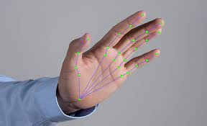

## HAND GESTURE CONTROL SYSTEM

## Abstract

The Hand Gesture Control System is a Python application designed to provide users with a hands-free control interface for their computer. By utilizing a webcam, the app detects hand gestures in real-time and translates them into various actions, such as mouse clicks, copying, selecting, scrolling, and adjusting volume. This project aims to offer an intuitive and accessible way for users to interact with their devices, particularly beneficial for individuals with limited mobility or those seeking an alternative input method.

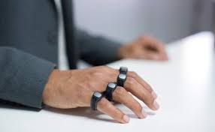

## Features

* **Real-time Hand Gesture Detection:** Utilizes the MediaPipe library to track hand movements and recognize gestures.
* **Action Control:** Performs various actions based on detected hand gestures, including clicking, copying, selecting, scrolling, and adjusting volume.
* **Cursor Movement:** Allows users to control the cursor on the screen by moving their hands.
* **User Interface:** Provides a simple graphical interface with start and stop buttons for controlling hand gesture detection.

## Demo

* 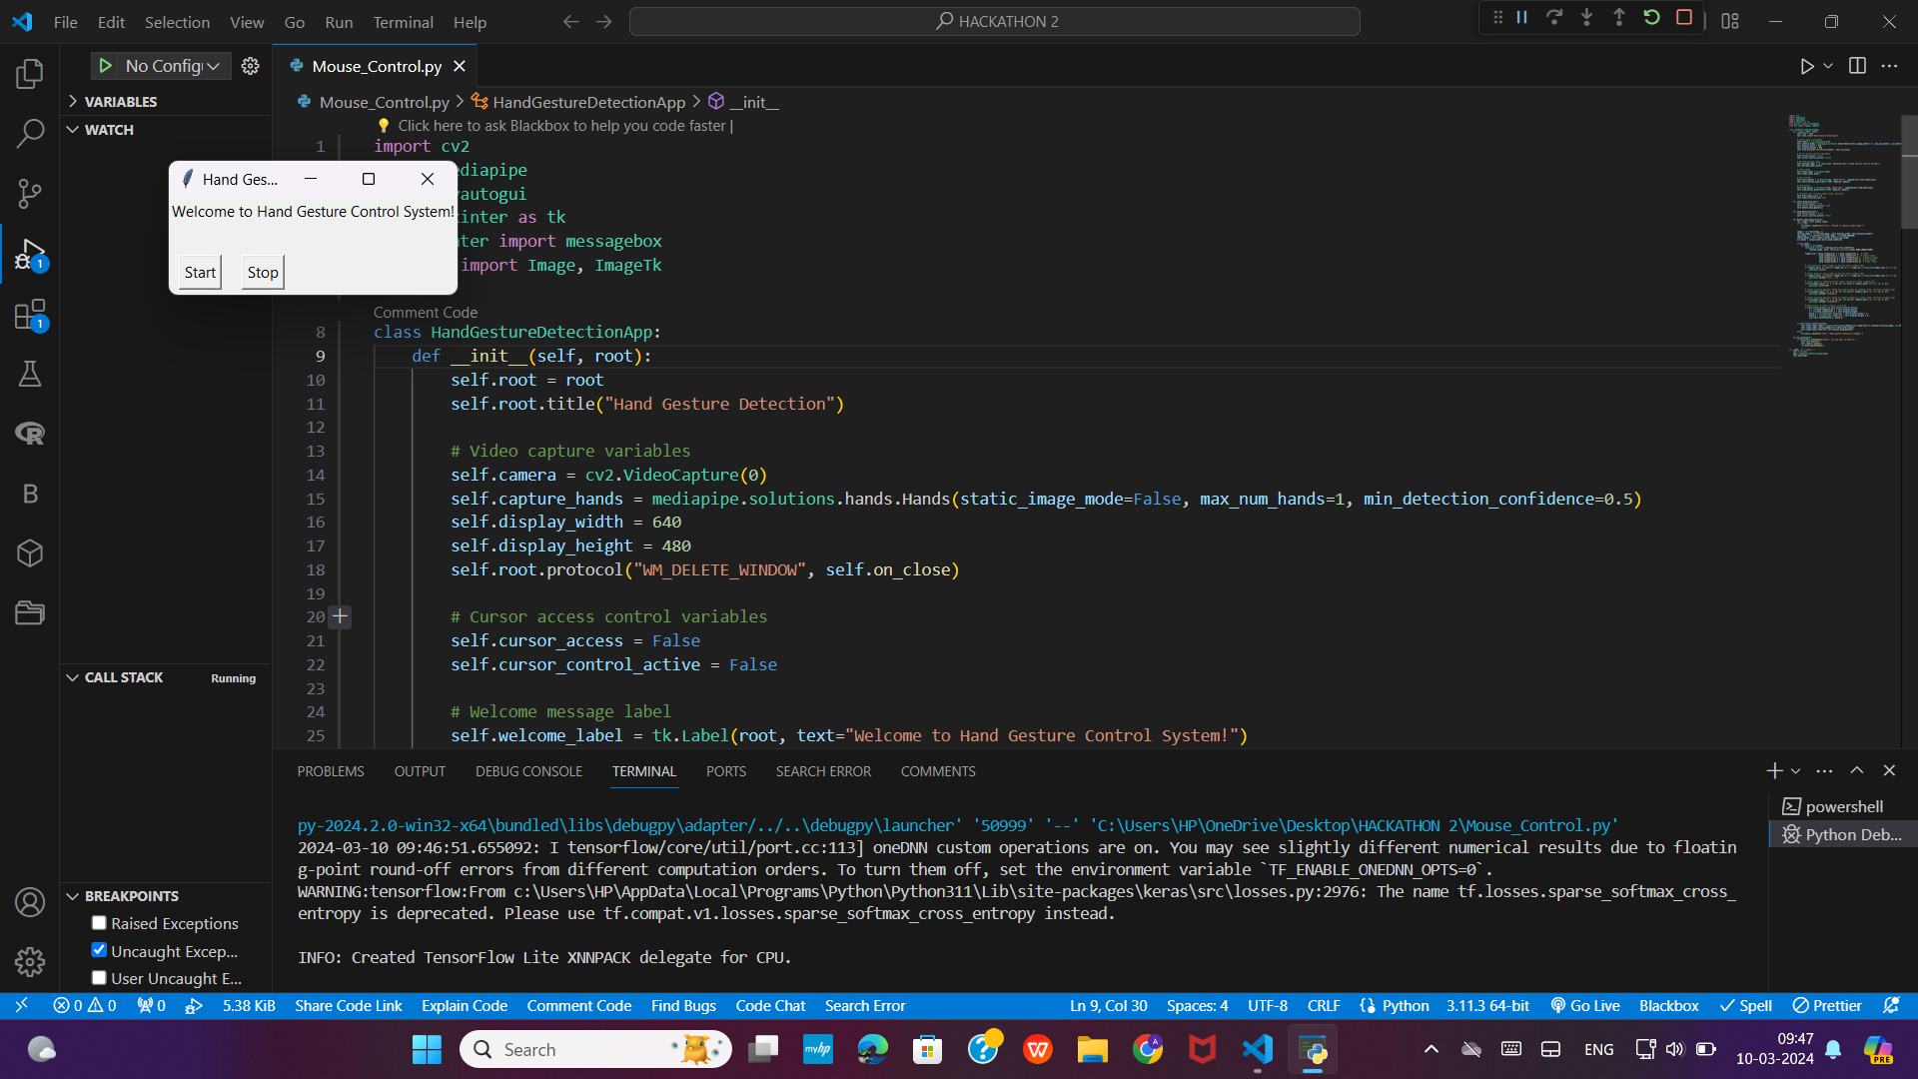Message Box for GUI to user to start or stop the hand gesture tracking.

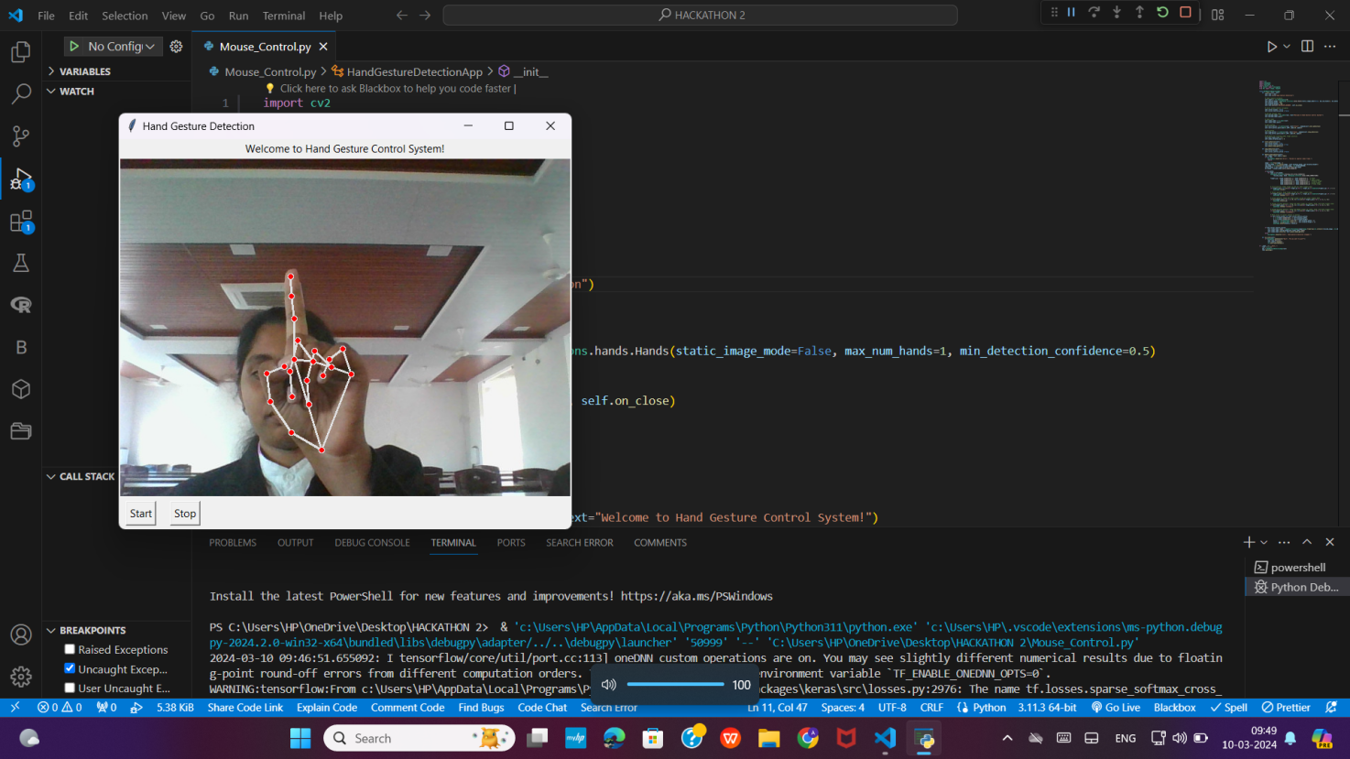

* Click gesture : Index finger up and all other fingers down.

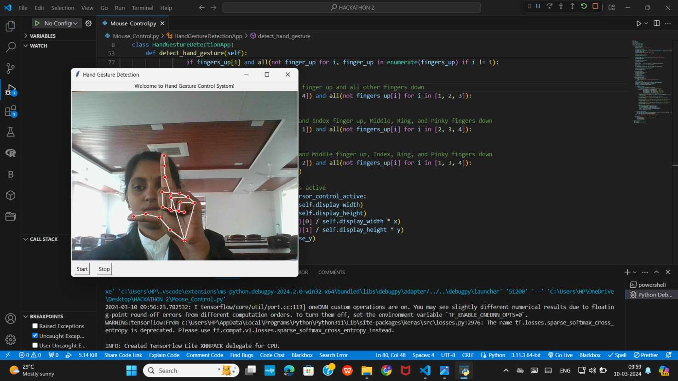

* Volume increase gesture : Thumb and Index finger up and all other fingers down.

## Screenshot (91)

* Volume decrease gesture : Thumb and Middle finger up and all other fingers down.

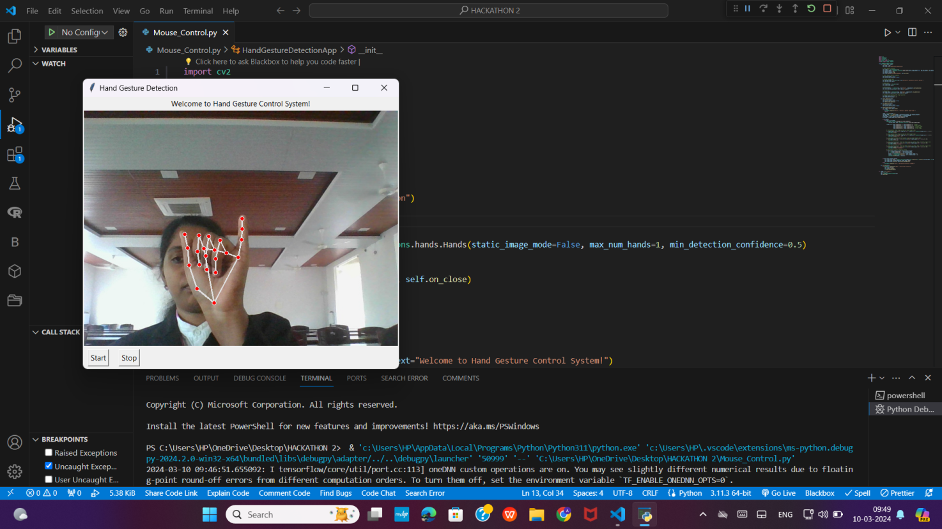

* Scroll gesture : Thumb and Pinky finger up and all other fingers down.

## Screenshot (87)

* Message Box to user to stop the hand gesture tracking.

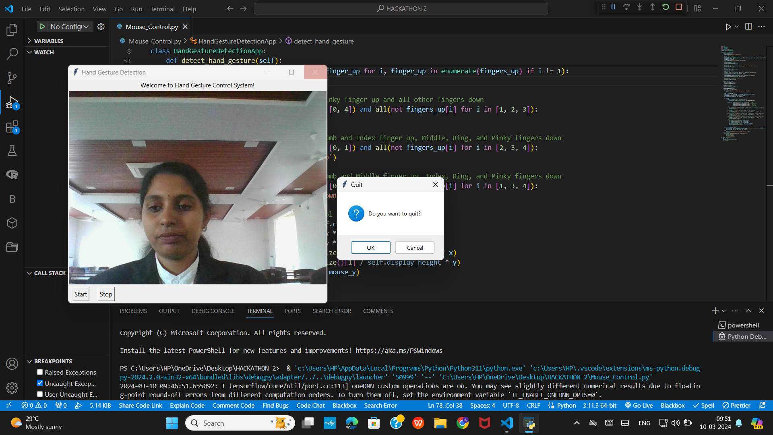

* Message Box to ask the user to quit the processing.

## preencoded.pngRequirements

* Python 3.x
* OpenCV
* MediaPipe
* PyAutoGUI
* Tkinter
* PIL

## Installation

###### Install dependencies:

pip install opencv-python

pip install mediapipe

pip install pyautogui

pip install pillow

###### Run the application:

python Mouse_Control.py

## Implementation

1. Launch the application.
2. Click the "Start" button to begin hand gesture detection.
3. Perform hand gestures in front of the webcam to control actions:

Click: Raise index finger with other fingers down.

Select: Raise ring finger with other fingers down.

Scroll: Raise thumb and pinky finger with other fingers down.

Volume Increase: Raise thumb and index finger with other fingers down.

Volume Decrease: Raise thumb and middle finger with other fingers down.

1. Click the "Stop" button to stop hand gesture detection.
2. Close the application window to exit.

## Note

* Ensure that your webcam is properly configured and accessible by OpenCV.
* Adjust the detection confidence and other parameters in the code as needed for optimal performance.
* The application is tested on Windows but should work on other platforms with minor adjustments.